**WAINGANGA POLYTECHNIC, SAKOLI**

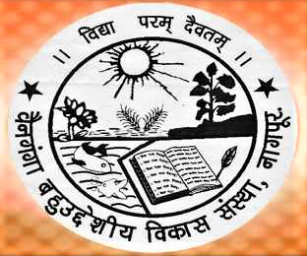

**Session 2017-2018**

**A PROJECT REPORT ON**

“ONLINE COLLEGE MANAGEMENT SYSTEM”

**: SUBMITTED BY:**

ABHILASHA K. KARANJEKAR

KIRTI T. CHIRWATKAR OMITA R. RINAITKAR LILESHWAR R. DHARMIK TUSHAR T. KHOBRAGADE

GUIDED BY hOD

MR. A. M. GAJBHIYE Mr. A. I. RAMTEKE

(Dept. of computer sci. and engg.) (Dept. of computer sci. and engg.)

**A PROJECT REPORT ON**

“ONLINE COLLEGE MANAGEMENT SYSTEEM”

Submitted in

**Partial fulfillment of the requirement for the award of Diploma in computer Science & Engineering.**

**: SUBMITTED BY:**

ABHILASHA K. KARANJEKAR

KIRTI T. CHIRWATKAR OMITA R. RINAITKAR LILESHWAR R. DHARMIK TUSHAR T. KHOBRAGADE

**Under The Guidance Of**

Mr. A. M. GAJBHIYE

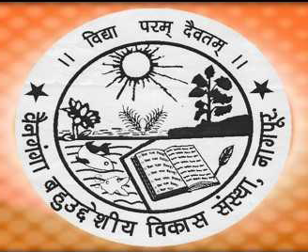

**Department of Computer Science & Engineering.**

**Wainganga Polytechnic, Sakoli**

**Session 2017-2018**